Java web application is stateless application by default because the http protocol is stateless protocol by default. For every request one separate con will be created between browser and server and that connection will be closed automatically once the response of that request comes back to browser, Due to this the state/data of one request/connection can not be used in another request/connection.

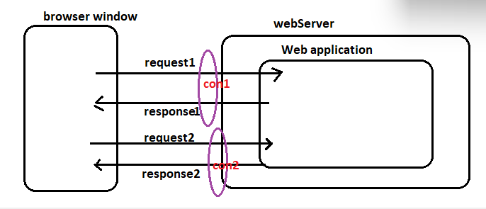

We want to change our web application as stateful web application. For this we need to use one or another sessionTracking/Session Management Technique.

For this we need to use one or another Session Tracking/Session Management Technique.

The following are session tracking and session Management techniques

1. Hidden Form fields (un official)
2. Http Cookies
3. Http Session with cookies
4. Http Session with URL ReWriting.

* By applying these techniques we can make the web application as stateful web application through the protocol “http” is stateless by default.